**K L E F deemed to be University**

**Green Fields, Vaddeswaram, Guntur (Dt) :: 522502**

**Department of Computer Science Engineering**

**Project Based Lab Report**

**OBJECT ORIENTED PROGRAMMING**

**17 CS 2002**



**Submitted by**

K. SUDHARSAN REDDY- 170030689

B. GANESH BABU - 170030120

P. SOBHANA - 170031015

U. MAHESH - 170031326

**Under Guidance of**

Mr. B. Sekhar Babu

**II Year Engineering Course Work**

**2018-19**



**DECLARATION**

We declare that the project work entitled “**STUDENT INFORMATION SYSTEM**“was carried out by us during 2018-19, and this work is not the same as that of any other and has not been submitted for award of any other degree/diploma

Place: Vaddeswaram Signature of the Student

Date: 16/11/2018



**K L E F deemed to be UNIVERSITY**

**Green fields,Vaddeswaram,Guntur Dist**.

**CERTIFICATE**

This is to certify that this project work entitled “**STUDENT INFORMATION SYSTEM**” by is a bonafide work carried out by them in Department of Computer Science and Engineering.

Project supervisor Head of the Department

Mr. B. Sekhar Babu Mr. V. Hari Kiran



**ACKNOWLEDGEMENT**

We express my sincere gratitude to **Mr. B. Sekhar Babu** sir for encouraging and guiding us to undertake this project work. We express my deep sense of gratitude to **Mr. V. Hari Kiran** sir and our beloved course lecturers of department for their encouragement.

Place: Vaddeswaram

Date: 16/11/2018

K. SUDHARSAN REDDY- 170030689

B. GANESH BABU - 170030120

P. SOBHANA - 170031015

U. MAHESH - 170031326

**TABLE OF CONTENTS**

|  |  |  |
| --- | --- | --- |
| **S.No** | **Topic** | **Page No** |
| 1 | ABSTRACT | 6 |
| 2 | INTRODUCTION | 7 |
| 3 | SOFTWARE AND HARDWARE REQUIREMENTS | 8 |
| 4 | FUNCTIONAL REQUIREMENTS | 9 |
| 5 | NON-FUNCTIONAL REQUIREMENTS | 10 |
| 6 | MODULE DESCRIPTION | 11 |
| 7 | SOURCE CODE | 12-37 |
| 8 | OUTPUT SCREENS | 38-44 |
| 9 | CONCLUSION | 45 |

**ABSTRACT**

The aim of this project is meant for capturing and maintaining students, student’s registrations for the courses, attendance, course-based registrations and making the students to know their grading subject wise, semester wise and considering all the subjects that they have undergone as on date of reporting. The students can use the system and monitor their own progress.

**Modules**

**Student Registration:** Here this module having some of the functions that are required **to** add a student and delete a student with modify a student at last report List of students registered.

**Student Attendance:** Here this module captures attendance, report subject wise attendance, report day wise attendance considering all the subjects and report the students having less than 75% attendance.

**Course Based Registration:** Here this module capture and maintain the details of the courses offered and maintain the details of the faculty offering the courses, register the students for various courses and the list of students registered for each of the course.

**Student Grading:** Here this module reports the subject wise grading and reports the semester wise grading then report cumulative grading and at last it will report the list of grades along with weights.

**INTRODUCTION**

Student Information System (SIS) is a web-based application software designed to introduce a conducive and structured information exchange environment for integrating students, parents, teachers and the administration of a school or college. Some of the other software packages available for this purpose include Student Management System (SMS), Student Information Management System (SIMS) and Student Records System (SRS). These software systems enable educational institutions to supervise student-related activities such as keeping records of tests or examinations conducted, attendance, appraisal on performance including details of marks scored, particulars of everyday school attendance, and all other institution-related activities; in short, they provide a complete student records system. They are designed with diverse application potentials ranging from simple management of students’ records at school to management of all student-related functions as well as administrative functions of a university or a chain of educational establishments.

**SOFTWARE AND HARDWARE REQUIREMENTS**

|  |  |  |
| --- | --- | --- |
| Hardware/Software | Hardware / Software element | Specification /version |
| Hardware | Processor | Intel core to duo |
| RAM | 1 GB |
| Hard Disk | 100 GB |
| Software | OS | Windows XP |
| C++ related IDE | Turbo C++ |

**FUNCTIONAL REQUIREMENTS**

|  |  |  |  |
| --- | --- | --- | --- |
| Module Number | Module Name | Function Serial | Function Title |
|  | Student Registration Module |  | Add a student |
|  | Delete a student |
|  | Modify a student |
|  | Report List of students registered |
|  | Student Attendance Module |  | Capture attendance |
|  | Report subject wise attendance |
|  | Report day wise attendance considering all the subjects |
|  | Report the students having less than 75% attendance |
|  | Course Based Registration |  | Capture and Maintain the details of the courses offered |
|  | Capture and maintain the details of the faculty offering the courses |
|  | Register the students for various courses |
|  | List of students registered for each of the course |
| 4. | Student Grading |  | Report subject wise grading |
|  | Report semester wise grading |
|  | Report cumulative Grading |
|  | Report list of grades along with weights |

**NON-FUNCTIONAL REQUIREMENTS**

**External Interfaces**

No External interfaces is required for this System.

**User Interfaces**

In user interfaces we can use any smart devices which support web services.

**Software Interfaces**

Software interfaces are ASP.NET as a front end and Microsoft SQL Server.

**MODULE DESCRIPTION**

**Modules**

**Student Registration:** Here this module having some of the functions that are required **to** add a student and delete a student with modify a student at last report List of students registered.

**Student Attendance:** Here this module captures attendance, report subject wise attendance, report day wise attendance considering all the subjects and report the students having less than 75% attendance.

**Course Based Registration:** Here this module capture and maintain the details of the courses offered and maintain the details of the faculty offering the courses, register the students for various courses and the list of students registered for each of the course.

**Student Grading:** Here this module reports the subject wise grading and reports the semester wise grading then report cumulative grading and at last it will report the list of grades along with weights.

**SOURCE CODE**

**MODULE 1:**

import java.util.*;

import java.io.*;

class O

{

public static void main(String[] args)throws IOException {

int i,num;

int choice=0,option;

String name;

boolean flag=true;

boolean quit = false;

BufferedReader br = new BufferedReader(new InputStreamReader(System.in));

System.out.println("\n\t\t\tStudent information system");

while(flag)

{

System.out.println("\n Menu");

System.out.println("1. Create student File");

System.out.println("2. Add a student to file");

System.out.println("3. Modify a student ");

System.out.println("4. Delete a student");

System.out.println("5.Report ");

System.out.print("Enter your choice: ");

choice= Integer.parseInt(br.readLine());

switch(choice)

{

case 1:

FileWriter fout = new FileWriter("student.txt");// Create a file.

System.out.println("How many records? ");//Read data from Keyboard

num= Integer.parseInt(br.readLine());

for(i=0;i<num;i++)

{

System.out.println("ENTER STUDENT ID:");

int Student_ID=Integer.parseInt(br.readLine());

System.out.println("ENTER STUDENT NAME:");

String Student_Name=br.readLine();

System.out.println("ENTER STUDENT DATE OF BIRTH IN WORDS:");

String DOB= br.readLine();

System.out.println("ENTER STUDENT ADDRESS:");

String Address= br.readLine();

System.out.println("ENTER STUDENT AGE:");

int age=Integer.parseInt(br.readLine());

System.out.println("ENTER STUDENT STUDENT CGPA:");

float cgpa=Float.parseFloat(br.readLine());

System.out.println("\n");

Formatter fmt1 = new Formatter();

fmt1.format("%10d\n %10s\n %10s\n %10s\n %2d\n %4f\n",Student_ID,Student_Name,DOB,Address,age,cgpa);

fout.write(fmt1+"\r\012");

}

fout.close();

System.out.println("File is created");

break;

case 2:

System.out.print("How many records? ");

num= Integer.parseInt(br.readLine());

if(num<=0)

{System.out.print("invalid number");break;

}

// Append to the File.

FileWriter fout1 = new FileWriter("student.txt",true);

for(i=0;i<num;i++)

{

System.out.println("ENTER STUDENT ID:");

int Student_ID=Integer.parseInt(br.readLine());

System.out.println("ENTER STUDENT NAME:");

String Student_Name=br.readLine();

System.out.println("ENTER STUDENT DATE OF BIRTH IN WORDS:");

String DOB= br.readLine();

System.out.println("ENTER STUDENT ADDRESS:");

String Address= br.readLine();

System.out.println("ENTER STUDENT AGE:");

int age=Integer.parseInt(br.readLine());

System.out.println("ENTER STUDENT STUDENT CGPA:");

float cgpa=Float.parseFloat(br.readLine());

System.out.println("\n");

Formatter fmt2 = new Formatter();

fmt2.format("%10d\n %10s\n %10s\n %10s\n %2d\n %4f\n ",Student_ID,Student_Name,DOB,Address,age,cgpa);

fout1.write(fmt2+"\r\012");

}

fout1.close();

System.out.println("new records are added");

break;

case 3:

System.out.print("enter modify Id: ");

int sid = Integer.parseInt(br.readLine());

FileReader fin1 = new FileReader("student.txt");

Scanner sc1 = new Scanner(fin1);

while(sc1.hasNextInt())

{

int Student_ID=sc1.nextInt();

String Student_Name=sc1.next();

String DOB= sc1.next();

String Address= sc1.next();

int age=sc1.nextInt();

float cgpa=sc1.nextFloat();

if(Student_ID==sid)

{

fin1.close();

FileWriter fout3 = new FileWriter("student.txt");

System.out.println("ENTER STUDENT ID:");

Student_ID=Integer.parseInt(br.readLine());

System.out.println("ENTER STUDENT NAME:");

Student_Name=br.readLine();

System.out.println("ENTER STUDENT DATE OF BIRTH IN WORDS:");

DOB= br.readLine();

System.out.println("ENTER STUDENT ADDRESS:");

Address= br.readLine();

System.out.println("ENTER STUDENT AGE:");

age=Integer.parseInt(br.readLine());

System.out.println("ENTER STUDENT STUDENT CGPA:");

cgpa=Float.parseFloat(br.readLine());

System.out.println("\n");

Formatter fmt3 = new Formatter();

fmt3.format("%10d\n %10s\n %10s\n %10s\n %2d\n %4f\n ",Student_ID,Student_Name,DOB,Address,age,cgpa);

fout3.write(fmt3+"\r\012");

fout3.close();

}

else

{

System.out.println("there is no student with that id number");

}

}

break;

case 4:

System.out.print("enter delete Id: ");

int sd = Integer.parseInt(br.readLine());

File fin4 = new File("student.txt");

FileReader fin = new FileReader("student.txt");

FileWriter fd = new FileWriter("d.txt");

File fd1 = new File("d.txt");

int k;

Scanner sc4 = new Scanner(fin);

while(sc4.hasNextInt())

{

int Student_ID=sc4.nextInt();

String Student_Name=sc4.next();

String DOB= sc4.next();

String Address= sc4.next();

int age=sc4.nextInt();

float cgpa=sc4.nextFloat();

if(Student_ID!=sd)

{

Formatter fmt4 = new Formatter();

fmt4.format("%10d\n %10s\n %10s\n %10s\n %2d\n %4f\n ",Student_ID,Student_Name,DOB,Address,age,cgpa);

fd.write(fmt4+"\r\012");

}

}

System.out.println("Delete suceesfull");

fin4.delete();

fd1.renameTo(fin4);

fd.close();

break;

case 5:

FileReader fin5 = new FileReader("student.txt");//Read data from file

Scanner sc2 = new Scanner(fin5);

while(sc2.hasNextInt())

{

int Student_ID=sc2.nextInt();

String Student_Name=sc2.next();

String DOB= sc2.next();

String Address= sc2.next();

int age=sc2.nextInt();

float cgpa=sc2.nextFloat();

Formatter fmt5 = new Formatter();

fmt5.format("id: %10d\n Name: %10s\n DOB: %10s\n address: %10s\n Age: %2d\n CGPA: %4f\n ",Student_ID,Student_Name,DOB,Address,age,cgpa);

System.out.println(fmt5);

}

fin5.close();

break;

case 6:

flag=false;

break;

default:System.out.println("Wrong Choice!!");

}

}

}

}

**MODULE 2:**

import java.util.*;

import java.io.*;

class Module2{

public static void main(String[] args) throws Exception{

Scanner sc=new Scanner(System.in);

int n,t;

while(1==1){

System.out.print("Functions are...............\n");

System.out.print("====================================================\n");

System.out.println("1.Capturing attendence for all students");

System.out.println("2.Report subject wise attendance for students");

System.out.println("3.Report day wise attendance considering all the subjects");

System.out.println("4.Report the students having less than 75% attendance");

System.out.println("5.Display all Details of Attendence of students");

System.out.print("\n====================================================\n");

System.out.print("Enter your choice:");

int h=sc.nextInt();

System.out.println("");

if(h==5)

break;

switch(h){

case 1:{

java.io.File file=new java.io.File("student_attendence.txt");

java.io.File file1=new java.io.File("student.txt");

java.io.File file2=new java.io.File("attendence.txt");

if(file.exists())

{

System.out.println("\n");

}

java.io.PrintWriter o=new java.io.PrintWriter(file);

java.io.PrintWriter o1=new java.io.PrintWriter(file1);

java.io.PrintWriter o2=new java.io.PrintWriter(file2);

System.out.print("Enter the number of students:");

n=sc.nextInt();

System.out.print("\n");

int i,j;

o.print("Name\t");

o.print("\t");

o.println("Attendence");

for(i=0;i<n;i++){

j=i+1;

System.out.println(j+" Student details:\n");

System.out.print("Enter the student name:");

String s=sc.next();

System.out.print("\n");

System.out.print("Enter the student Attendence:");

String s1=sc.next();

System.out.print("\n");

o.print(s+"\t");

o.println("\t"+s1);

o1.println(j+"."+s);

o2.println(s1);

}

System.out.println("Student_Attendence file is created\n");

System.out.println("Go to \'function 2\' to report Subject wise attendence\n");

o.close();

o1.close();

o2.close();

break;

}

case 2:{

java.io.File file1=new java.io.File("subject_wise_attendence.txt");

if(file1.exists())

{

System.out.println("\n");

}

java.io.PrintWriter o = new java.io.PrintWriter(file1);

int c=0;

System.out.println("Students are:\n");

BufferedReader br = new BufferedReader(new FileReader("student.txt"));

for (String line; (line = br.readLine()) != null;) {

System.out.println(line);

c++;

}

System.out.print("\n");

int i,j;

n=c;

o.print("Student\t");

o.print("Maths\t");

o.print("Data Structers\t");

o.println("OOPS\t");

for(i=0;i<n;i++){

j=i+1;

System.out.println(j+" Student Subject Wise Attendence:\n");

System.out.print("Enter the student name:");

String s=sc.next();

System.out.print("\n");

System.out.print("Enter the Maths Attendence:");

String s1=sc.next();

System.out.print("\n");

System.out.print("Enter the Data Structures Attendence:");

String s2=sc.next();

System.out.print("\n");

System.out.print("Enter the OOPS Attendence:");

String s3=sc.next();

System.out.print("\n");

o.print(s+"\t");

o.print(s1+"\t");

o.print(s2+"\t");

o.print("\t"+s3);

}

System.out.println("subject_wise_attendence.txt file is created\n");

System.out.println("Go to \'function 3\' to report day wise attendence\n");

o.close();

break;

}

case 3:{

int c=0;

BufferedReader br = new BufferedReader(new FileReader("student.txt"));

for (String line; (line = br.readLine()) != null;) {

System.out.println(line);

c++;

}

java.io.File file1=new java.io.File("day_wise_attendence.txt");

if(file1.exists())

{

System.out.println("\n");

}

java.io.PrintWriter o=new java.io.PrintWriter(file1);

System.out.print("\n");

int i,j;

n=c;

o.print("Student\t");

System.out.print("Enter the number of days:");

int k=sc.nextInt();

for(i=0;i<k;i++){

j=i+1;

o.print("Day"+j);

o.print("\t");

}

o.println("\n");

for(i=0;i<n;i++){

System.out.println((i+1)+" Student Day Wise Attendence:\n");

System.out.print("Enter the student name:");

String s=sc.next();

o.print(s+"\t");

System.out.print("\n");

for(j=1;j<=k;j++){

System.out.print("Is Student present or absent on"+j+"day:");

String s1=sc.next();

System.out.println();

o.print(s1+"\t");

}

o.println();

}

System.out.println("day_wise_attendence.txt file is created\n");

System.out.println("Go to \'function 4\' to report below 75% Attendence\n");

o.close();

break;

}

case 4:{

int c=0;

BufferedReader br = new BufferedReader(new FileReader("student_attendence.txt"));

for (String line; (line = br.readLine()) != null;) {

System.out.println(line);

c++;

}

java.io.File file1=new java.io.File("detained_list.txt");

if(file1.exists())

{

System.out.println("\n");

}

java.io.PrintWriter o = new java.io.PrintWriter(file1);

o.print("Student\t");

o.println("Pass or Fail\t");

o.println();

n=c;

BufferedReader br1 = new BufferedReader(new FileReader("attendence.txt"));

for (String line; (line = br1.readLine()) != null;) {

System.out.print("Enter the student name:");

String s=sc.next();

System.out.println("\n");

o.print(s+"\t");

int tt=Integer.parseInt(line);

if(tt>=75){

System.out.println("Student Passed");

System.out.println("\n");

o.println("Pass");

}

else if(tt<75){

System.out.println("Student Failed\n");

o.println("Fail");

}

}

System.out.println("Detained_list file is created\n");

o.close();

break;

}

}

}

System.out.println("*****************************************************");

System.out.println("Students Attendence:");

System.out.println("");

BufferedReader br = new BufferedReader(new FileReader("student_attendence.txt"));

for (String line; (line = br.readLine()) != null;) {

System.out.println(line);

}

System.out.println("*****************************************************");

System.out.println("Subject Wise Attendence:");

System.out.println("");

BufferedReader br1 = new BufferedReader(new FileReader("subject_wise_attendence.txt"));

for (String line; (line = br1.readLine()) !=null;) {

System.out.println(line);

}

System.out.println("*****************************************************");

System.out.println("Day Wise Attendence is:");

System.out.println("");

BufferedReader br2 = new BufferedReader(new FileReader("day_wise_attendence.txt"));

for (String line; (line = br2.readLine()) !=null;) {

System.out.println(line);

}

System.out.println("*****************************************************");

System.out.println("Detained List is:");

System.out.println("");

BufferedReader br3 = new BufferedReader(new FileReader("detained_list.txt"));

for (String line; (line = br3.readLine()) !=null;) {

System.out.println(line);

}

System.out.println("*****************************************************");

}

}

**MODULE 3:**

import java.util.*;

import java.lang.*;

import java.io.*;

class CourseBasedRegistration

{

Scanner sc=new Scanner(System.in);

int course_id[]=new int[26];

String course_name[]=new String[26];

String faculty_name[]=new String[26];

String faculty_course[]=new String[26];

int student_id[]=new int[26];

String student_name[]=new String[26];

String course[]=new String[26];

void course(int no){

int n=no;

for(int i=0;i<n;i++)

{

System.out.println("Enter id and name of course"+(i+1)+":");

course_id[i]=sc.nextInt();

course_name[i]=sc.next();

}

for(int i=0;i<n;i++)

{

System.out.println("Course id="+course_id[i]);

System.out.println("course name is "+course_name[i]);

}

}

void faculty(int no)

{

int n=no;

for(int i=0;i<n;i++)

{

System.out.println("Enter faculty name and course");

faculty_name[i]=sc.next();

faculty_course[i]=sc.next();

}

for(int i=0;i<n;i++)

{

System.out.println("Faculty name is "+faculty_name[i]);

System.out.println("Course offered by "+faculty_name[i]+" : "+faculty_course[i]);

}

}

int num;

void student(int no)

{

num=no;

for(int i=0;i<num;i++)

{

System.out.println("Enter student id,name and course");

student_id[i]=sc.nextInt();

student_name[i]=sc.next();

course[i]=sc.next();

}

}

void list_of_students()

{

for(int i=0;i<num;i++)

{

System.out.println(student_name[i]+" registered for the course "+course[i

}

}

}

class CourseRegistration

{

public static void main (String[] args) throws IOException

{

CourseBasedRegistration ob=new CourseBasedRegistration();

ob.course(3);

ob.faculty(3);

ob.student(5);

ob.list_of_students();

}

}

**MODULE 4:**

import java.util.*;

import java.io.*;

class Internalmarks

{

Displaybasicinfo oo=new Displaybasicinfo();

int Im[],Em[],Em1[],att[],n,Tm[],Am,count,Epm[],Total;

double percentage;

String s[],Es[],grade,Ep[],Ef[],Ir,Ir1;

Scanner S=new Scanner(System.in);

void Internalmarks()

{

System.out.print("\n\n\t\tEnter no of subjects :");

n=S.nextInt();

oo.year=3;

String[] s= new String[n];

String[] Es=new String[n];

String[] Ep=new String[n];

String[] Ef=new String[n];

String[] Ir=new String[n];

String[] Ir1=new String[n];

int[] Em=new int[n];

int[] Tm=new int[n];

int[] Epm=new int[n];

System.out.print("\n\n\t\tEnter names of the subjects :");

for(int i=0;i<n;i++)

{

System.out.printf("\n\n\t\ts[%d]:",i+1);

s[i]=S.next()+S.nextLine();

}

System.out.print("\n\n\t\tEnter INTERNAL MARKS in each subject: ");

int[] Im=new int[n];

for(int i=0;i<n;i++)

{

System.out.print("\n\n\t\t"+s[i]+":");

Im[i]=S.nextInt();

}

System.out.print("\n\n\t\tEnter ATTENDACE % in each subject");

int[] att=new int[n];

for(int i=0;i<n;i++)

{

System.out.print("\n\n\t\t Attendance in "+s[i]+":");

att[i]=S.nextInt();

}

System.out.print("\n\n\t\t----------------------------------------");

System.out.print("\n\n\t\t\tSTUDENT ACADEMIC RECORDS");

System.out.print("\n\n\t\t----------------------------------------");

for(int i=0;i<n;i++)

{

if((Im[i]<20&&att[i]<65)||(Im[i]>20&&att[i]<65)||(Im[i]<20&&att[i]>65))

{

System.out.print("\n\n\t\tMarks in "+s[i]+":"+Im[i]+"\n\n\t\tAttendance in "+s[i]+":"+att[i]);

Ir[i]="DETAINED";

}

if(att[i]>65&&att[i]<75&&Im[i]>20)

{

System.out.print("\n\n\t\tMarks in "+s[i]+":"+Im[i]+"\n\n\t\tAttendance in "+s[i]+":"+att[i]);

Ir[i]="ELIGIBLE WITH CONDONATION";

}

if(Im[i]>20&&att[i]>75)

{

System.out.print("\n\n\t\tMarks in "+s[i]+":"+Im[i]+"\n\n\t\tAttendance in "+s[i]+":"+att[i]);

Ir[i]="ELIGIBLE";

}

}

System.out.print("\n\n\t\tSubjects eligible for External exam are :");

for(int i=0;i<n;i++)

{

if((att[i]>65&&att[i]<75&&Im[i]>20)||(Im[i]>20&&att[i]>75))

{

count=count+1;

Es[i]=s[i];

System.out.print("\n\n\t\t"+Es[i]);

}

}

System.out.print("\n\n\t\tEnter marks in External exam:");

for(int i=0;i<n;i++)

{

if((att[i]>65&&att[i]<75&&Im[i]>20)||(Im[i]>20&&att[i]>75))

{

Es[i]=s[i];

System.out.print("\n\n\t\t"+Es[i]+":");

Em[i]=S.nextInt();

}

}

for(int i=0;i<n;i++)

{

if(Em[i]<20&&Em[i]>=0)

{

Ef[i]=Es[i];

System.out.print("\n\n\t\t "+Es[i]+":"+Em[i]+":FAIL");

Ir1[i]="FAIL";

}

else if(Em[i]>=21&&Em[i]<=50)

{

Ep[i]=Es[i];

Epm[i]=Em[i];

System.out.print("\n\n\t\t "+Ep[i]+":"+Em[i]+":PASS");

Ir1[i]="PASS";

}

}

System.out.print("\n\n\t\t--------------------------------------------------------");

System.out.print("\n\n\t\t\t Subjects in "+oo.year+" Semester");

System.out.print("\n\n\t\t--------------------------------------------------------");

for(int i=0;i<n;i++)

{

System.out.print("\n\n\t\t"+s[i]);

}

System.out.print("\n\n\t\t\t\tINTERNAL MARKS REPORT ");

System.out.print("\n\n\t\t--------------------------------------------------------");

System.out.print("\n\n\t\t\tMARKS\t ATTENDANCE\t RESULT");

System.out.print("\n\n\t\t--------------------------------------------------------");

for(int i=0;i<n;i++)

{

System.out.print("\n\n\t\t"+s[i]+":\t"+Im[i]+"\t "+att[i]+"\t "+Ir[i]);

}

System.out.print("\n\n\t\t--------------------------------------------------------");

System.out.print("\n\n\t\t\tSubjects ELIGIBLE for external");

System.out.print("\n\n\t\t--------------------------------------------------------");

for(int i=0;i<n;i++)

{

if((att[i]>65&&att[i]<75&&Im[i]>20)||(Im[i]>20&&att[i]>75))

{

Es[i]=s[i];

System.out.print("\t\t\t"+Es[i]);

}

}

System.out.print(" ");

System.out.print("\n\n\t\t\t\tEXTERNAL MARKS REPORT ");

System.out.print("\n\n\t\t--------------------------------------------------------");

System.out.print("\n\n\t\t\t\tMARKS\t\tRESULT");

System.out.print("\n\n\t\t--------------------------------------------------------");

for(int i=0;i<n;i++)

{

if((att[i]>65&&att[i]<75&&Im[i]>20)||(Im[i]>20&&att[i]>75))

{

Tm[i]=Em[i]+Im[i];

System.out.print("\n\n\t\t"+Es[i]+":\t\t"+Tm[i]+"\t\t"+Ir1[i]);

Total=Total+Tm[i];

}

}

percentage=Total/count;

double CGPA=(percentage*9.5)/10;

System.out.println("\n\n\t\tC.G.P.A : "+CGPA);

System.out.print("\n\n\t\tPercentage in semester is:"+percentage);

System.out.println("\n\n\t\t\t\t\tGRADE POINT IS BASED ON PERCENTAGE OF ALL SUBJECTS");

if (percentage>=85){

System.out.println("\n\n\t\tGrade Is O");

System.out.println("\n\n\t\tGrade Point Is 10");

}

else if(percentage>=80 && percentage<85){

System.out.println("\n\n\t\tGrade Is A+");

System.out.println("\n\n\t\tGrade Point Is 9");

}

else if(percentage>=65 && percentage<80){

System.out.println("\n\n\t\tGrade Is A");

System.out.println("\n\n\t\tGrade Point Is 8");

}

else if(percentage>=60 && percentage<65){

System.out.println("\n\n\t\tGrade Is B+");

System.out.println("\n\n\t\tGrade Point Is 7");

}

else if(percentage>=50 && percentage<60){

System.out.println("\n\n\t\tGrade is B");

System.out.println("\n\n\t\tGrade Point Is 6");

}

else if(percentage>=45 && percentage<50){

System.out.println("\n\n\t\tGrade is C");

System.out.println("\n\n\t\tGrade Point Is 5");

}

else if(percentage>=40 && percentage<45){

System.out.println("\n\n\t\tGrade is P");

System.out.println("\n\n\t\tGrade Point Is 4");

}

else{

System.out.println("\n\n\t\tYou Are Fail");

System.out.println("\n\n\t\tGrade Point Is 0");

}

}

}

public class Grading

{

public static void main(String args[])

{

System.out.println("\n\n\t\tSTUDENT GRADING SYSTEM");

System.out.println("\n\n\t\t\tSUBJECT WISE GRADING");

System.out.println("\n\n\t\t\t\tSEMESTER WISE GRADING");

Internalmarks o=new Internalmarks();

o.Internalmarks(); } }

**OUTPUT SCREENS**

**MODULE 1:**

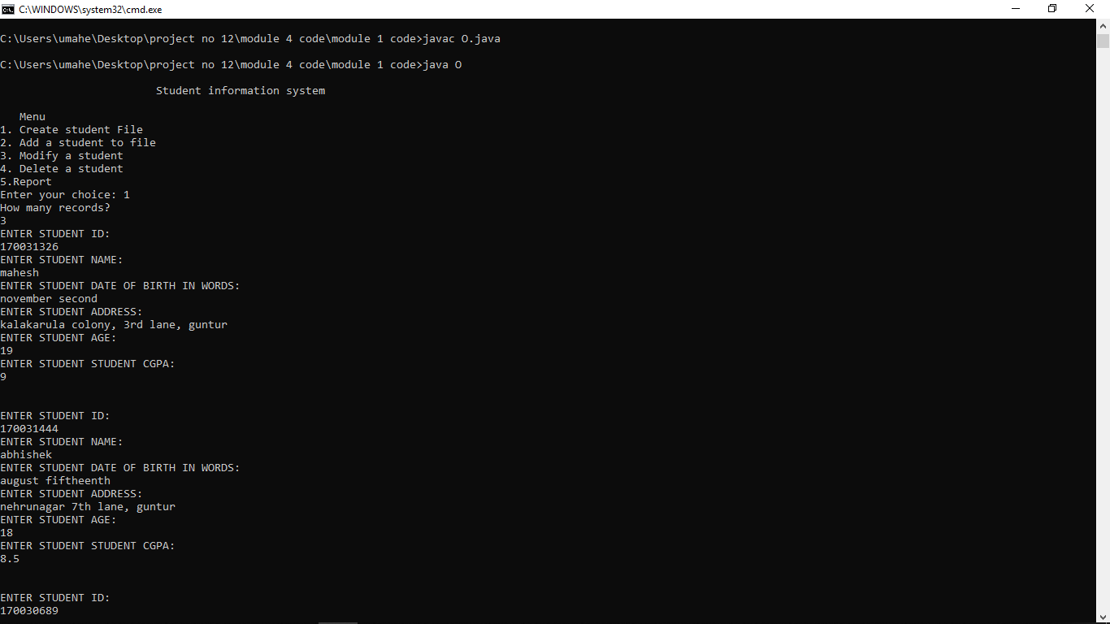

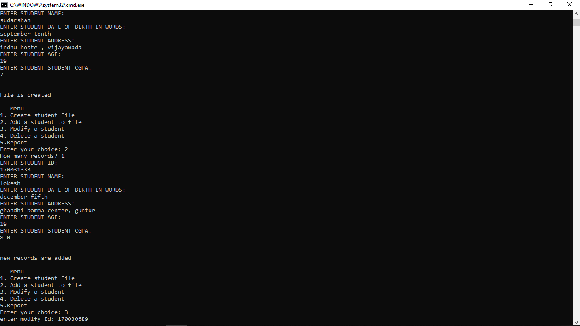

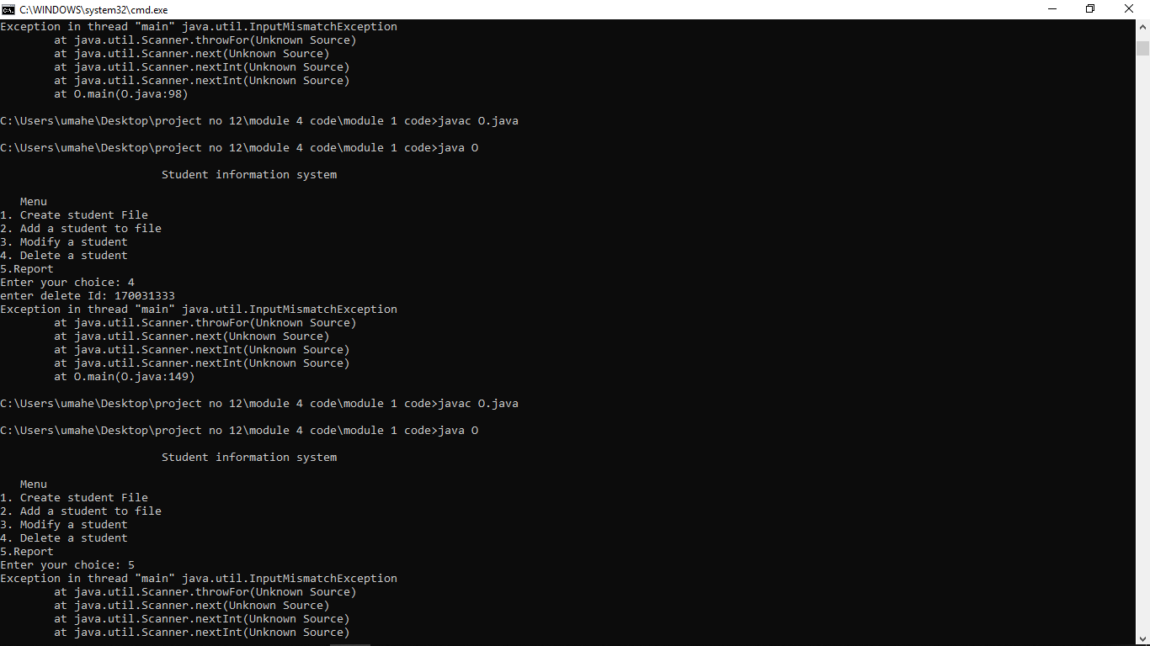

**MODULE 2:**

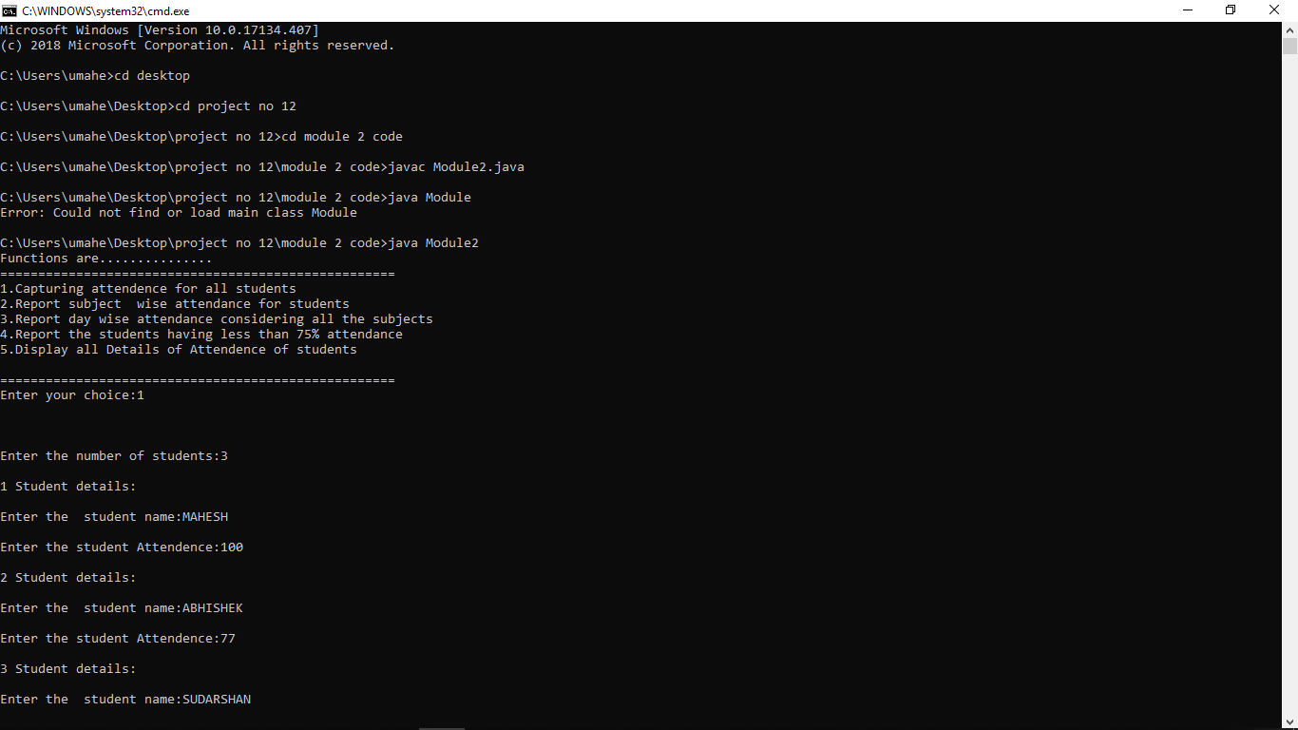

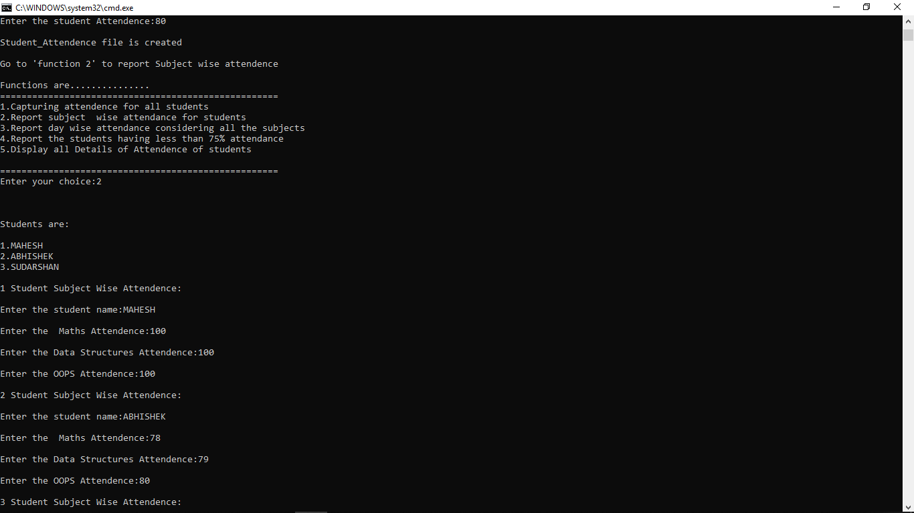

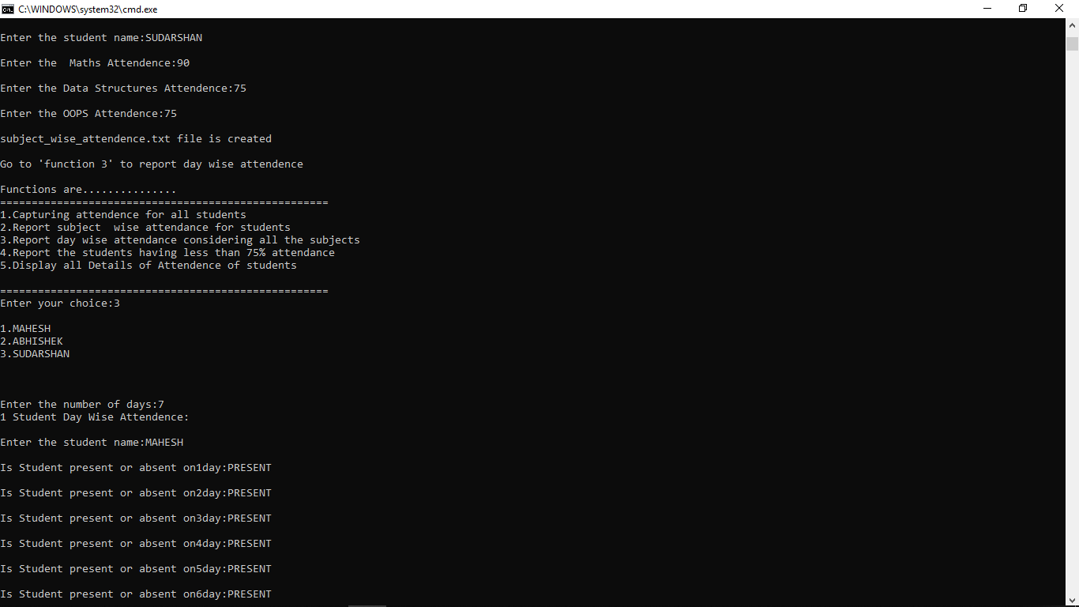

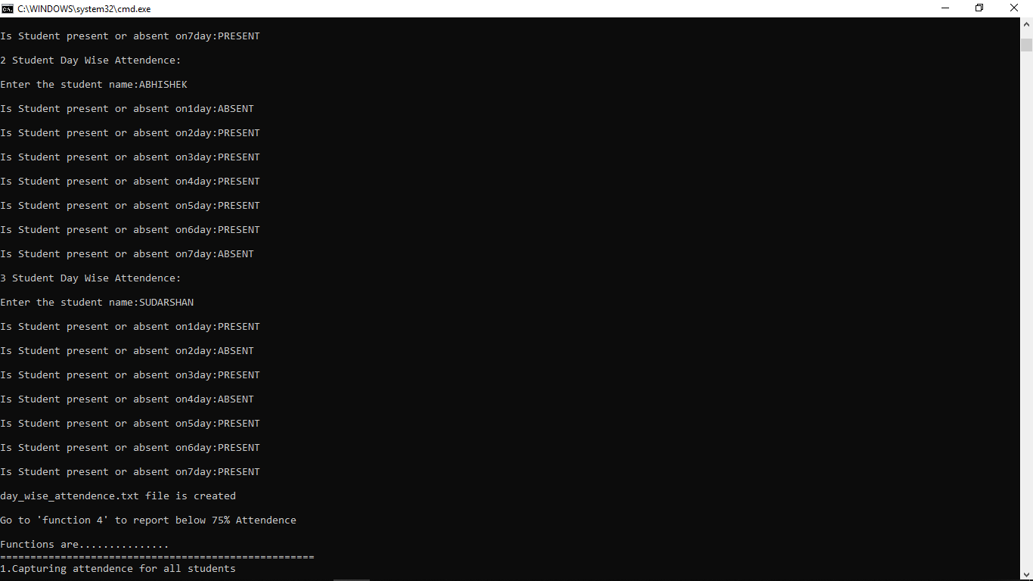

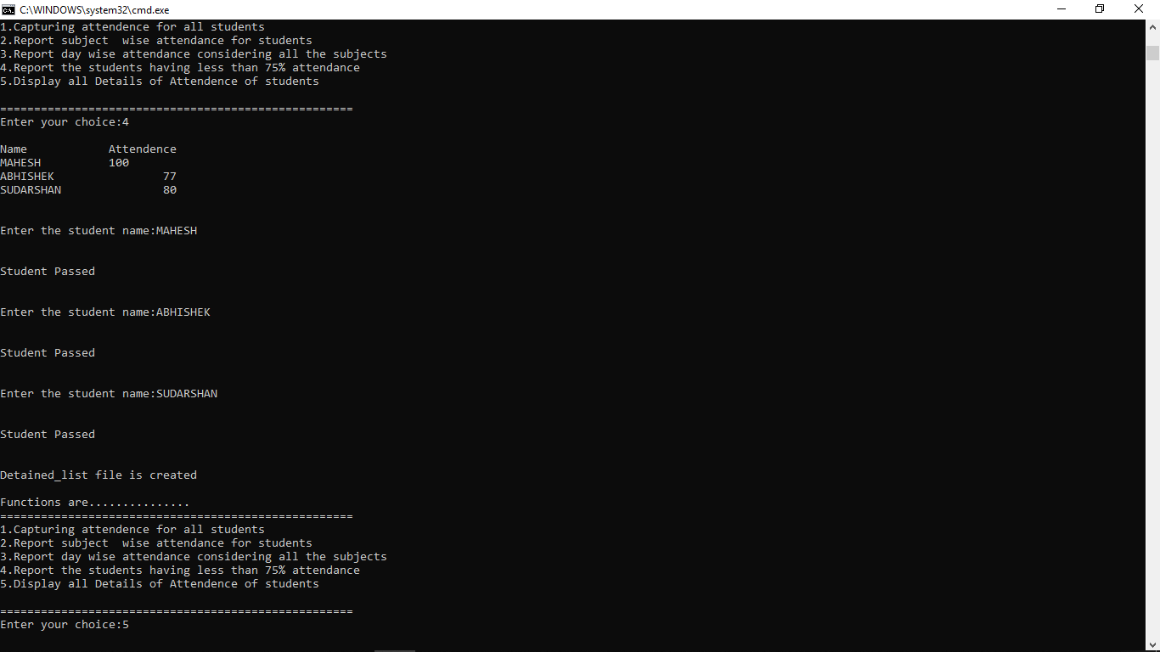

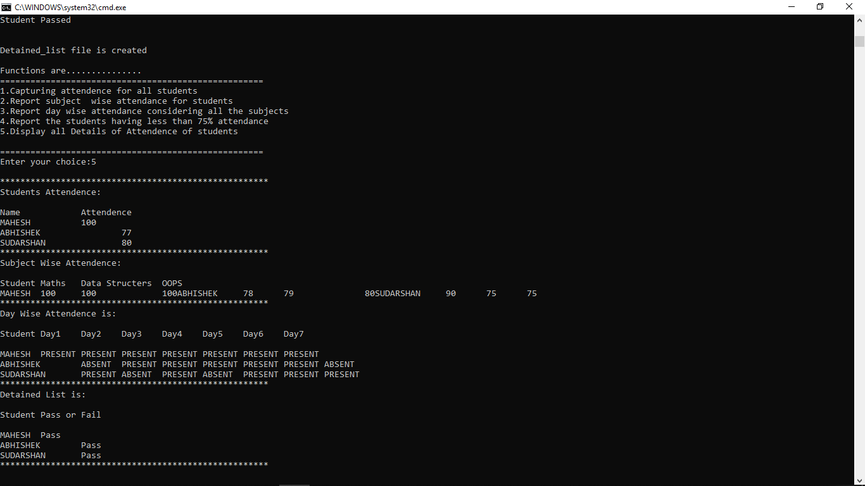

**MODULE 3:**

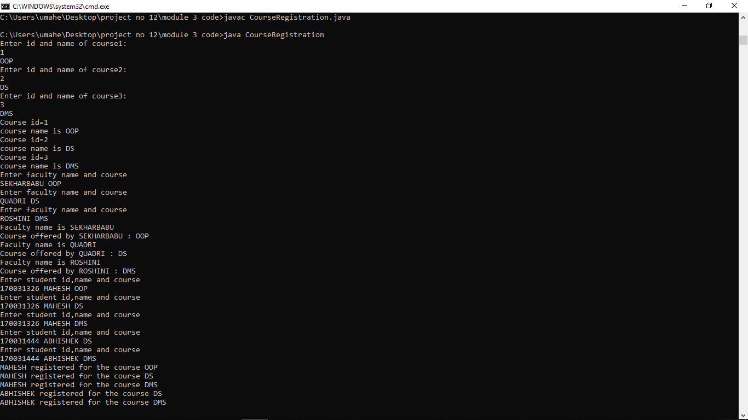

**MODULE 4:**

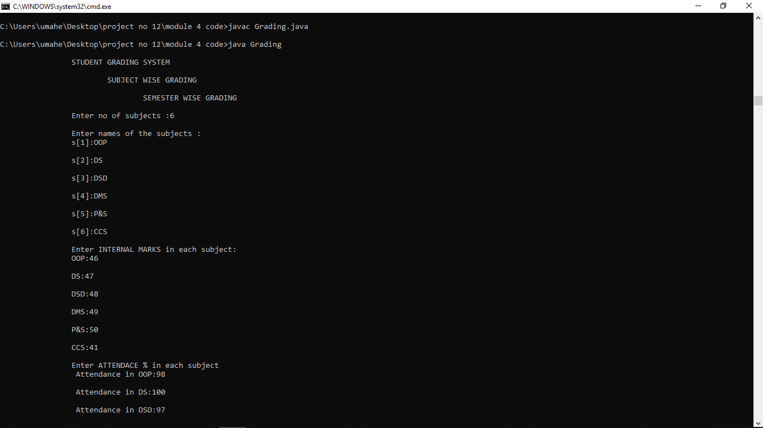

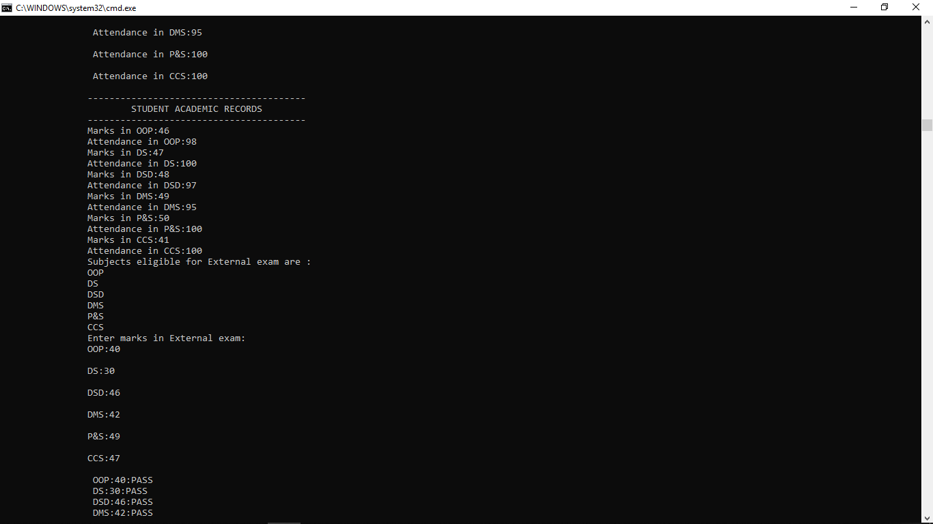

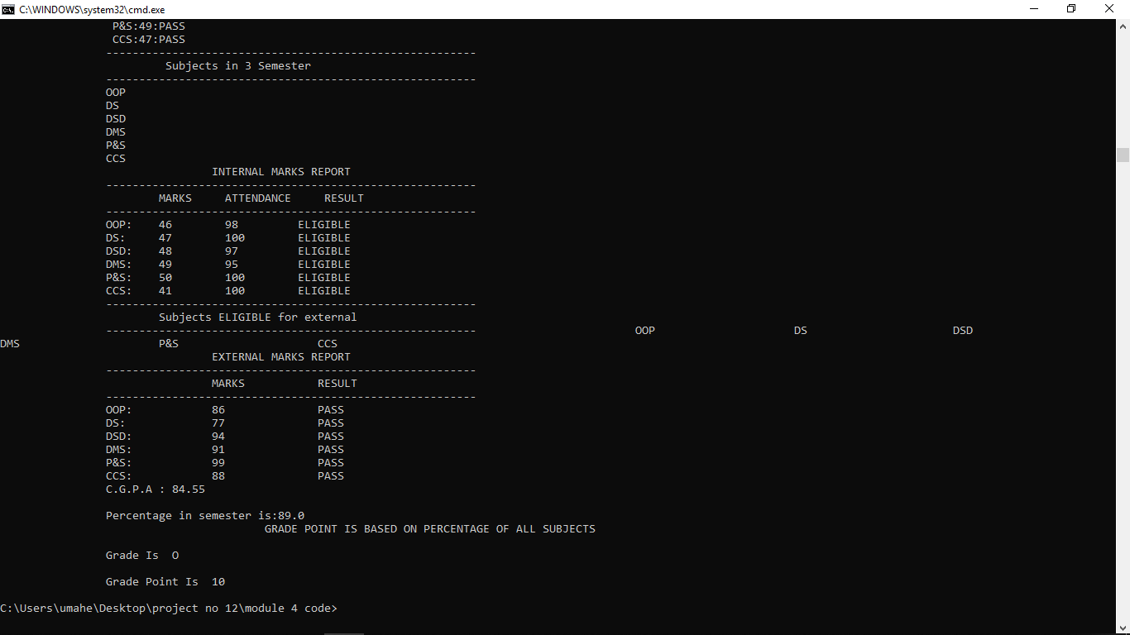

**CONCLUSION**

It is always prudent to opt for a student information system that is designed using modern system architecture to cope with changing requirements. This system should encompass very solid information coding and distinctly outlined business applications, separating the presentation of details and methods of support.